**Section 1:**

- Based on the report created, what is the approximate date and time of the attack?

The attack started at approximately 2 pm sunday Feb 23rd 2020.

- How long did it take your systems to recover?

It appears that the system recovered around 11pm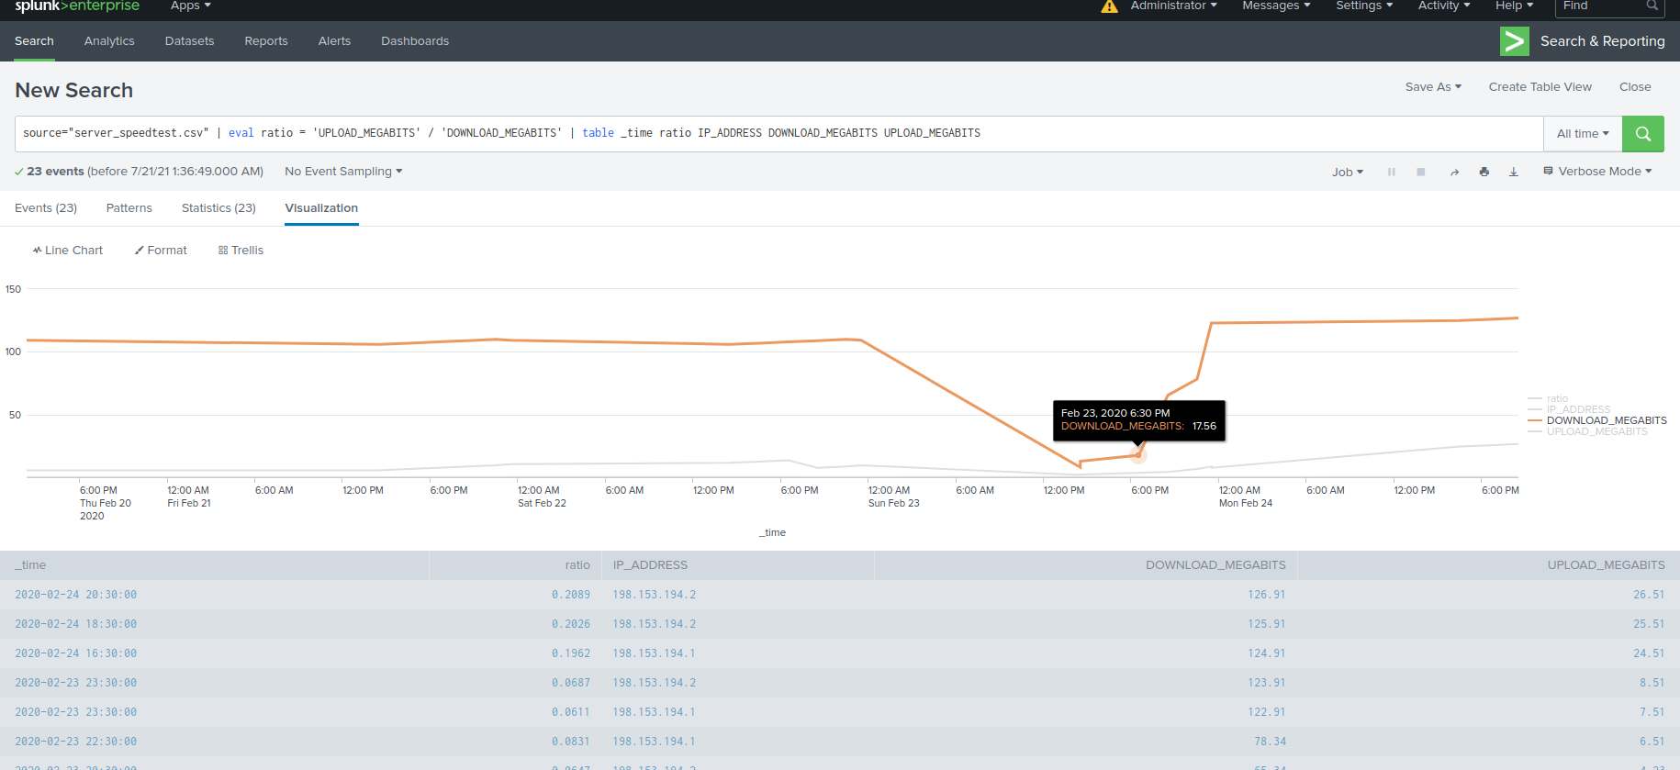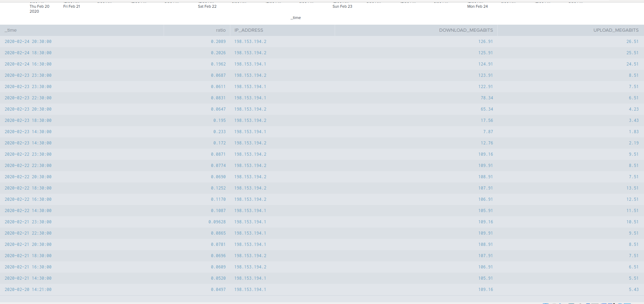

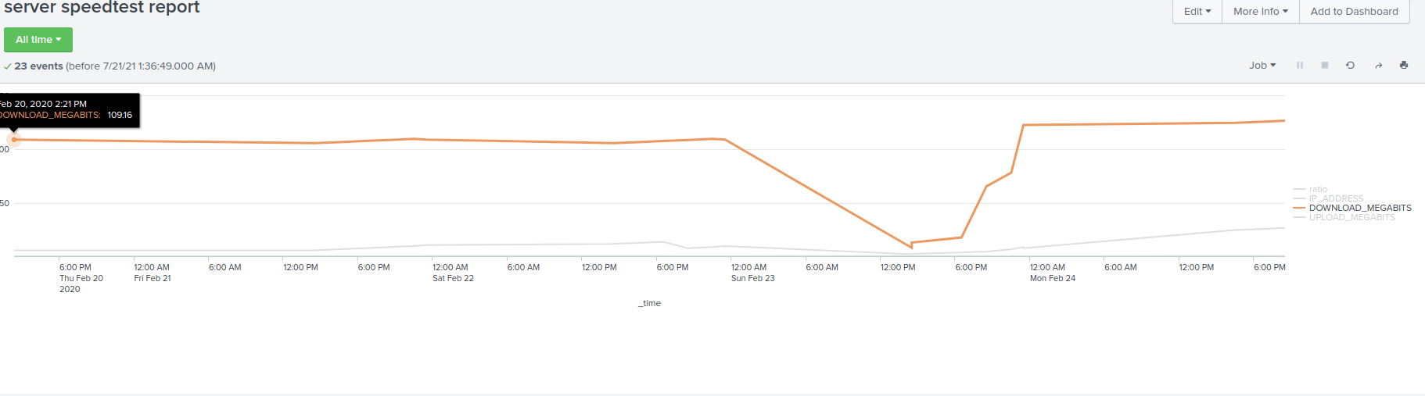

**Section 2:** 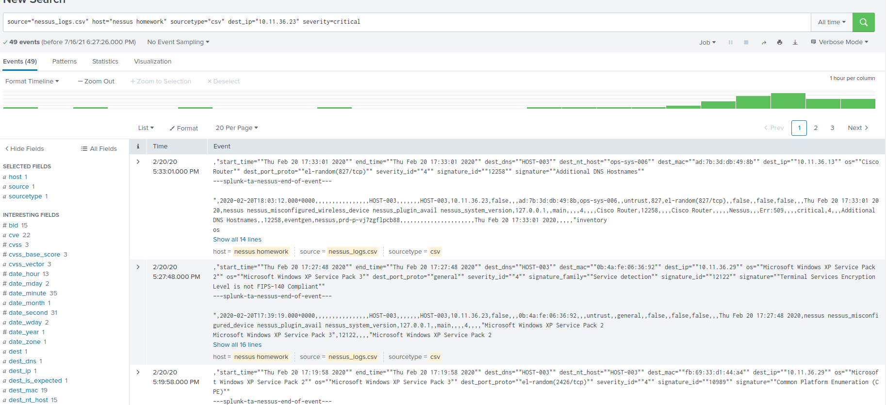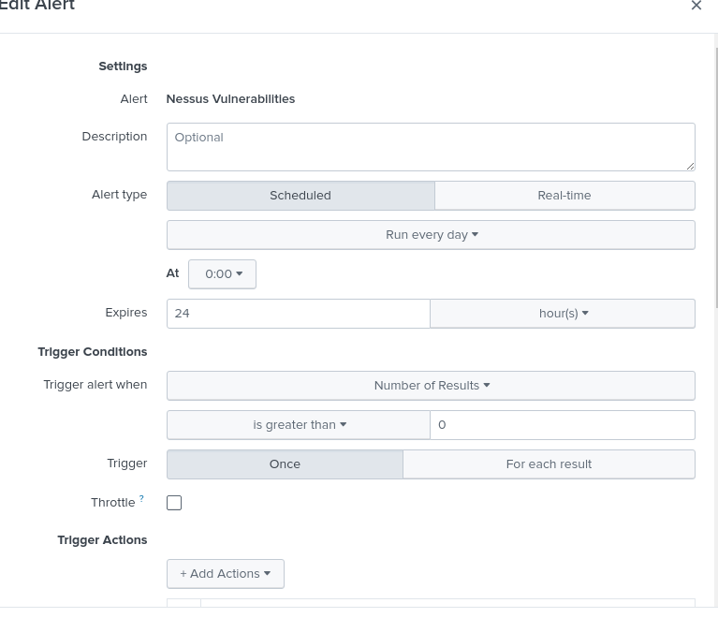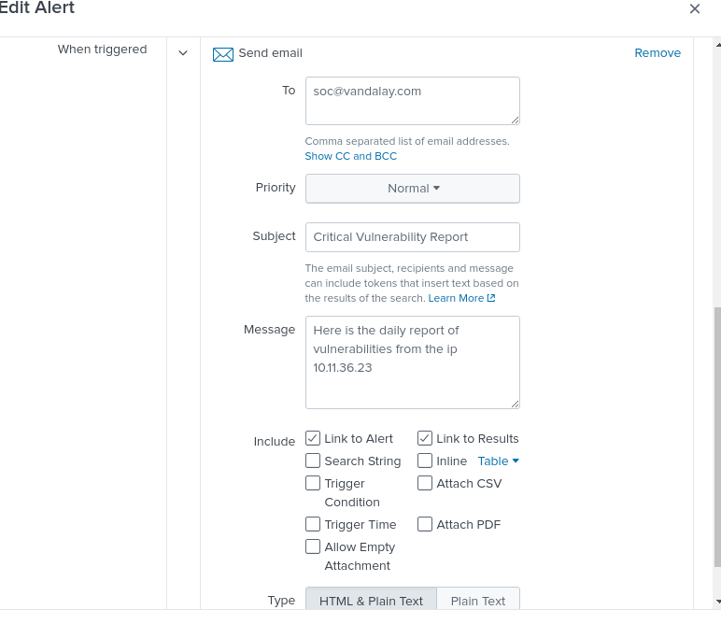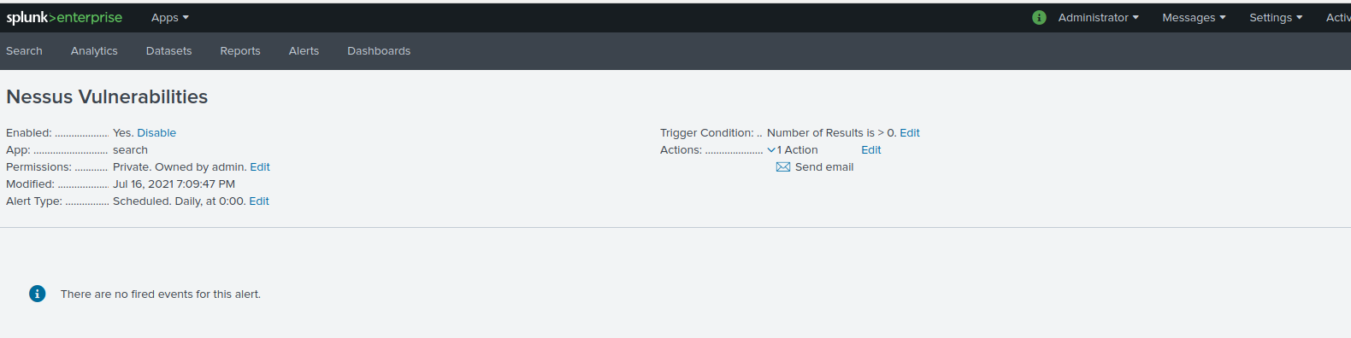

**Section 3:**

When did the brute force attack occur?

There was a significant increase in failed login attempts from 9am to 1pm on Friday Feb 21, 2020 indicating a brute force attack.

Determine a baseline of normal activity and a threshold that would alert if a brute force attack is occurring.

From looking at the logs it appears that on average about 34 failed login attempts is considered normal, with anything over 40 a threshold for an alert.

